# Querying the Dimensional Model (With Hint)

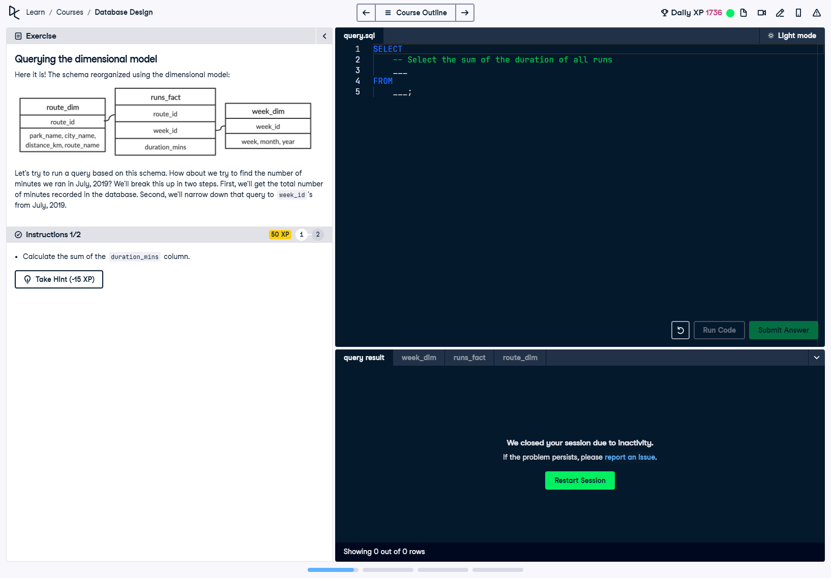

## Question

Here it is! The schema reorganized using the dimensional model:  
- route_dim: Contains details about the route (park name, city name, distance, and route name).  
- runs_fact: Contains facts such as duration_mins and foreign keys (route_id and week_id).  
- week_dim: Contains details about the week (week_id, week, month, and year).  
  
Let's try to run a query based on this schema. How about we try to find the number of minutes we ran in July, 2019? We'll break this up into two steps:  
1. First, we'll get the total number of minutes recorded in the database.  
2. Second, we'll narrow down that query to week_id's from July, 2019.

## AI-Generated Hint

Have you tried using the SUM function to calculate the total of the duration_mins column?  
  
SELECT   
 SUM(duration_mins)  
FROM   
 runs_fact;  
  
If this hint doesn't help out, take a look at the solution below.

## SQL Solution (Step 1)

-- Calculate the total duration of all runs  
SELECT SUM(duration_mins) AS total_duration  
FROM runs_fact;

## Answer Explanation (Step 1)

In this query, we use the SUM() function to calculate the total duration of all runs. The query targets the 'duration_mins' column in the 'runs_fact' table, which stores the duration of each run. The result is a single value representing the sum of all recorded durations.